**Assignment 3 Dion Chang – 20812576**

1. Plots of the bags used for Whole Blood, Platelets, and Packed Red Cells along with the forecasted simple moving average models are shown:

Figure . 3-days basis of number of blood bags as well as its forecasted models with N = 3, 5, and 7. Forecasted number of blood bags required for October 1st – October 3rd can be seen in this graph. Converted to containers by dividing number of blood bags by 5.

Raw data and how the simple moving average was created using Excel. This can be seen in the uploaded Excel file with worksheet named “Questions A + B + C.” The “N” values were chosen arbitrarily. Summary of forecasted number of containers required for October 1st – October 3rd shown below:

Table . Forecasted number of containers required for October 1st - October 3rd. It's the total number of blood bags within those 3-days divided by 5. Numbers rounded higher because logically speaking it is better to have an extra container.

|  |  |  |  |
| --- | --- | --- | --- |
| 2018-10-01 - 2018-10-03 | **N = 3** | **N = 5** | **N = 7** |
| Blood Bags | 247.6667 | 227.2 | 234.4286 |
| Containers | 49.53333 = ~50 | 45.44 = ~46 | 46.88571 = ~47 |

1. 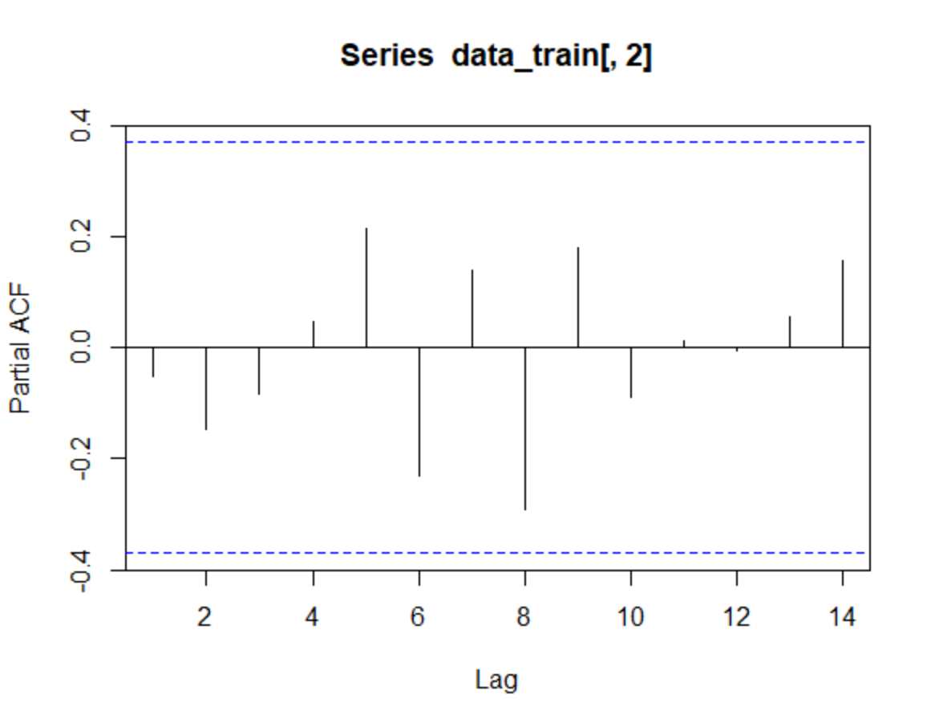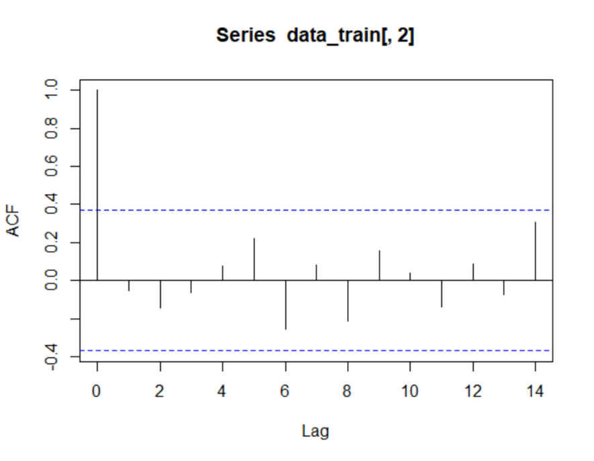From the residual ACF and PACF plots as shown in Figure 2 and 3, the AR model with p = 1 can be used. The ACF plot concluded that there is no evidence of non-stationarity, and the PACF plot shows no autocorrelation of residuals, so the model AR(1) can be accepted. Plots were created using R. The AR model was determined to be:

Figure 3. PACF plot shows no autocorrelation of residuals. Therefore, can accept model AR(1).

Figure 2. ACF plot concluded that there is no evidence of non-stationarity.

$y_{t}=212.1785-0.05209y_{t-1}+ ϵ_{t}$**or**

$$y_{t}=212.1785-0.05209y_{t-1}$$

Where yt is the dependent variable result, *c* is 212.1785, yt-1 is the independent variable, and $θ_{1}$ is -0.05209.

|  |  |  |  |  |  |  |  |  |
| --- | --- | --- | --- | --- | --- | --- | --- | --- |
| SUMMARY OUTPUT |  |  |  |  |  |  |  |  |
|  |  |  |  |  |  |  |  |  |
| *Regression Statistics* | |  |  |  |  |  |  |  |
| Multiple R | 0.052606 |  |  |  |  |  |  |  |
| R Square | 0.002767 |  |  |  |  |  |  |  |
| Adjusted R Square | -0.03712 |  |  |  |  |  |  |  |
| Standard Error | 91.82046 |  |  |  |  |  |  |  |
| Observations | 27 |  |  |  |  |  |  |  |
|  |  |  |  |  |  |  |  |  |
| ANOVA |  |  |  |  |  |  |  |  |
|  | *df* | *SS* | *MS* | *F* | *Significance F* |  |  |  |
| Regression | 1 | 584.9159151 | 584.9159 | 0.069377 | 0.794405104 |  |  |  |
| Residual | 25 | 210774.9359 | 8430.997 |  |  |  |  |  |
| Total | 26 | 211359.8519 |  |  |  |  |  |  |
|  |  |  |  |  |  |  |  |  |
|  | *Coefficients* | *Standard Error* | *t Stat* | *P-value* | *Lower 95%* | *Upper 95%* | *Lower 95.0%* | *Upper 95.0%* |
| Intercept | 212.1785 | 42.2366057 | 5.02357 | 3.51E-05 | 125.190607 | 299.1664 | 125.1906 | 299.1664 |
| Yt-1 | -0.05209 | 0.197781952 | -0.26339 | 0.794405 | -0.459434298 | 0.355245 | -0.45943 | 0.355245 |

The model forecasted 201.1344 blood bags, which is equal **to 40.22689 (round up to ~40) containers.**

1. MAD and RMSE measures were determined using Excel and summarized in the following table:

Table . RMSE and MAD values determined using Excel for Questions A and B.

|  |  |  |  |  |
| --- | --- | --- | --- | --- |
|  | **(A) Simple Moving Average** | | | **(B)** |
|  | **N = 3** | **N = 5** | **N = 7** | **AR Model** |
| **RMSE** | 59.90919054 | 23.57089 | 33.41086 | 56.71310405 |
| **MAD** | 57.55555556 | 22.6 | 28.38095 | 49.88365586 |

Based on MAD and RMSE, measures, the simple moving average forecasting model with N = 5 was determined to be the best. This is because the model was determined to have the lowest MAD and RMSE values. The smaller Root Mean Squared Error and Mean Absolute Deviation between forecast and actual results, the better.